
NORTHERN EDUCATION DIVISION MOCK EXAMINATION

2026 MALAWI SCHOOL CERTIFICATE OF EDUCATION EXAMINATION

GEOGRAPHY

Subject Number: M073/II
Thursday, 26th March Allowed: 2 hours
1:00pm-3:00pm
PAPER II
(100 marks)
HUMAN AND ECONOMIC GEOGRAPHY

Question  Number | Tick if  answered | Do not write in  these columns
1
2
3
4
5
Total
INSTRUCTIONS

- This paper contains 11 printed pages, please check.

- This paper has two sections, A and B. Answer all the questions in the spaces provided.

- Write your name on all pages.

- In the table provided on this page, tick against the question number you have answered.

- At the end of the examination, hand in your paper to the invigilator.

Section A (75 marks)
Answer all questions
- a i. Give any two examples of land locked countries in southern Africa.
___________________________________________________________________________________________________ (2 marks)
ii. Explain any two challenges associated with customs in international trade.
___________________________________________________________________________________________________________________________________________________________________________________________________________________ (4 marks)
iii. State any two economic benefits that Malawi gets from joining SADC.
______________________________________________________________________________________________________(2marks)
b. i. Explain how minerals are extracted using In Situ Leaching method.
_____________________________________________________________________________________________________________________________________________________________(3marks)
ii. State any two examples of minerals extracted using In Site Leaching method.
___________________________________________(2marks)
iii. Explaining any two factors to consider when mining an ore.
____________________________________________________________________________________________________________________________________________________________________________________________________________________(4marks)
iv. State any two effects of uranium mining on the economy of a Malawi.
_______________________________________________________________________________________________________(2marks)
c) i. Explain any one possible solution to endangered species.
______________________________________________________________________________________________(2 marks)
ii. Explain how the following factors can lead to extinction of wildlife species.
- Overspecialization
___________________________________________________________________________________________(2marks)
- Competition
__________________________________________________________________________________________(2marks)
- a. Figure 1 shows the type of energy. Use it to answer questions that follow;
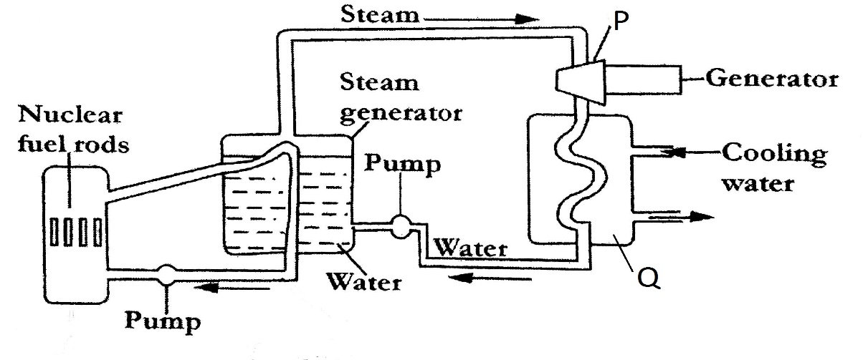
- Identify the type of energy shown in the diagram.
_________________________________________ (1mark)
- Name the parts labelled
P ________________________________________ (1mark)
Q _______________________________________ (1mark)
- Describe the process of energy production in figure 1.
___________________________________________________________________________________________________________________________________________(3marks)
- Describe any two disadvantages of damming of rivers in order to establish hydro-electric plants.
___________________________________________________________________________________________________________________________________________________________________________________________(4marks
b. i Explain ant two challenges associated with subsistence farming.
________________________________________________________________________________________________________________________________________________________________________________________________________________(4marks)
ii. State any two challenges faced in irrigation farming
______________________________________________________
(2marks)
iii. Explain any two environmental effects of rice farming.
________________________________________________________________________________________________________________________________________________________________________________________________________________(4marks)
iv. Give any one way that can be used to improve rice production in Malawi.
___________________________________________________
(1mark)
c. i. Mention any two crops associated with dairy farming in demark.
______________________________________________________(2marks)
ii. Explain any one challenge faced by dairy farmers in Denmark.
____________________________________________________________________________________________________(2marks)
- a. Figure 2 shows the type of industry. Use it to answer questions that follow;
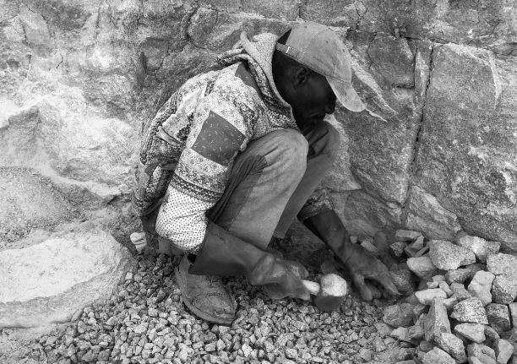
- Identify the type of industry shown in figure 2.
________________________________________ (1 mark)
- State any two characteristics of the industry shown in figure 2.
_______________________________________________________________________________________(2marks)
- Why the government of Malawi is emphasizing on the development of secondary industries? Explain two.
____________________________________________________________________________________________________________________________________________________________________________________________
(4marks)
b) Table 1 below shows car assembly by a company in one year. Use it to answer questions that follow;

Car | Percentage
Ford | 25
Tata | ?
Toyota | 20
Nissan | 22
- Calculate the percentage of Tata cars in the year.

(2marks)
- Using a radius of 2 cm, draw a pie chart to show the information in the table.
Pie Chart

(9marks)
c) i. Define the term Population explosion.
_____________________________________________________________________________________________________(1mark)
- State any two implications of youthful population.
_____________________________________________________________________________________________(2marks)
- Describe the Early Expanding stage of Demographic Transitional Model.
_____________________________________________________________________________________________(2marks)
- Give any two countries in the Low Stationary stage of the Demographic Transitional Model
_____________________________________________________________________________________________(2marks)

SECTION B (25 Marks)
Answer one question only.
- (a) i. Explain the importance of pressure in the formation of oil.
_______________________________________________________________________________________________(2marks)
- Explain how deforestation causes of energy crisis in Malawi.
________________________________________________________________________________________(2marks)
- State any two member countries of OPEC in Africa.
________________________________________ (2marks)
b. Figure 3 is world map showing major fishing grounds of the world. Use it to answer questions that follow;
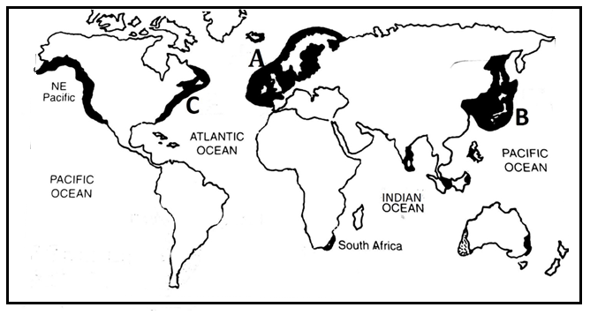
- Locate and name one major fishing ground in north Africa
_________________________________________(2marks)
- Name any two fishing areas in fishing ground marked C
_________________________________________(2marks)
- Explain any two physical factors that have influenced the growth of fishing ground labelled B.
____________________________________________________________________________________________________________________________________________________________________________________________________(4marks)
- Explain any one way which is used to deal with overfishing in fishing ground marked A.
___________________________________________________________________________________(2marks)
- i. Give any one non-human causes of desertification
__________________________________________ (1mark)
- Describe how industries cause air pollution
______________________________________________________________________________________________(2marks)
d. i. Mention any one place in Malawi which offers each of the following tourist functions;
- Mountaineering ________________________________ 1mark
- History and heritage ___________________________________1mark
ii. Explain any two strategies that can be used to improve tourism in Malawi.
____________________________________________________________________________________________________________________________________________________________________________________________________________(4marks)
- a. i. State any two differences between ocean liner and cargo liner.
______________________________________________________________________________________________(2marks)
ii. Explain any two factors that influence the choice of transport.
_____________________________________________________________________________________________________________________________________________________________________________________________________________(4marks)
b. Figure 4 shows locks operation. Use it to answer questions that follow
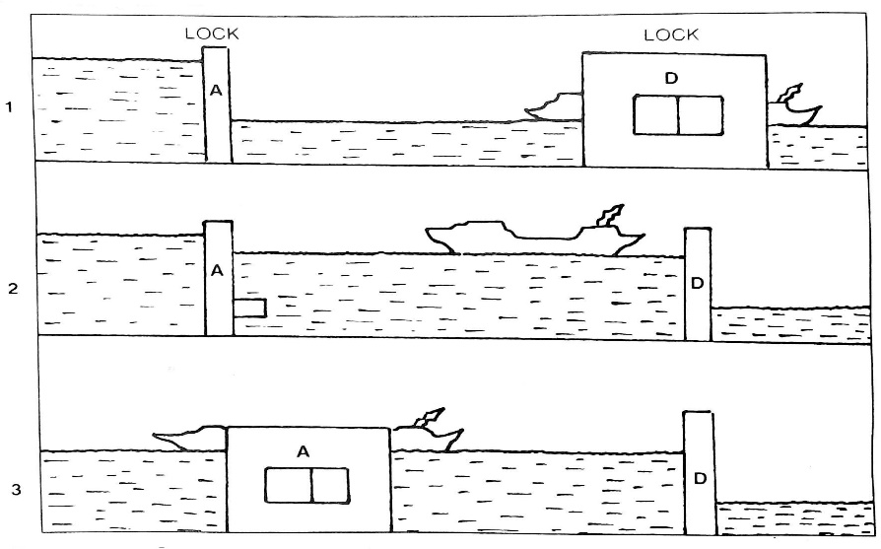
- Describe the process of lock operation in stages 1 to 3.
______________________________________________________________________________________________________________________________________(3marks)
- State any two challenges associated with the lock operation system.
____________________________________________________________________________________________(2marks)
- i. Explain any two economic advantages of recycling method of waste management.
__________________________________________________________________________________________________________________________________________________________________________________________ (4marks)
- State any two challenges faced in waste management in developing countries.
______________________________________________________________________________________(2mark)
- Calculate the dependency ratio for a country whose economically active people is estimated at 5, 740, 535 while non-economic active population is 19, 170, 780.

(2marks)
- State any two implications of high dependency ratio in a country.
______________________________________________________________________________________(2marks
- i. Explain any one way how Lilongwe city interacts with its hinterland.
_______________________________________________________________________________________________(2marks)
- State any two strategies for managing environmental challenges associated with urban settlements.
_____________________________________________________________________________________________
(2marks)
END OF QUESTION PAPER
NB. This paper contains 11 printed pages

